[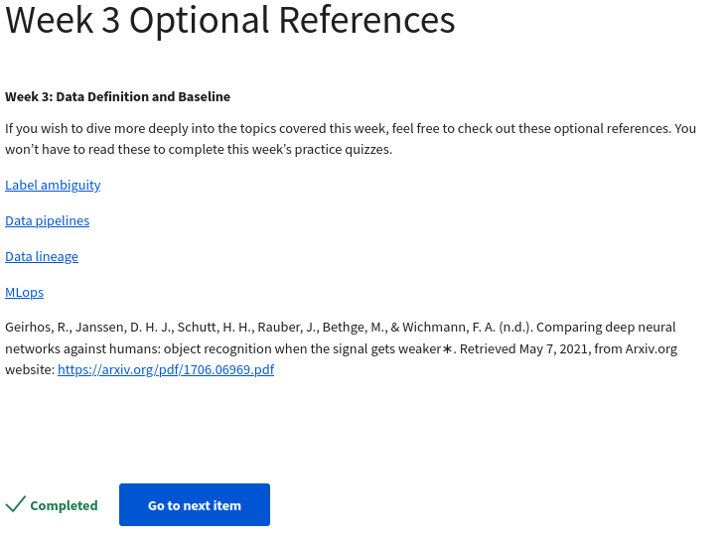https://csgaobb.github.io/Projects/DLDL.html](https://csgaobb.github.io/Projects/DLDL.html)

[https://cs230.stanford.edu/blog/datapipeline/#best-practices](https://cs230.stanford.edu/blog/datapipeline/" \l "best-practices)

https://blog.tensorflow.org/2021/01/ml-metadata-version-control-for-ml.html

https://cloud.google.com/blog/products/ai-machine-learning/key-requirements-for-an-mlops-foundation

Geirhos, R., Janssen, D. H. J., Schutt, H. H., Rauber, J., Bethge, M., & Wichmann, F. A. (n.d.). Comparing deep neural networks against humans: object recognition when the signal gets weaker∗. Retrieved May 7, 2021, from Arxiv.org website: <https://arxiv.org/pdf/1706.06969.pdf>